Supplier Bid Response - Question & Answer Board
Purpose is for Suppliers to ask sourcing event related questions, receive responses, read other supplier's questions and answers that have been made public, and respond to buyer-submitted questions.
- Checklist | Know your Sourcing Event Number, Sourcing Event Title, Bid Close Date, Question Submission Close Date, Login ID, and Password
- Supplier portal  Supplier can navigate from Georgia Procurement Registry (GPR) Open Bid Search to Jaggaer Supplier Network Public Bid Search.  Supplier can click on ‘View as PDF’ to see the detail requirements related to the event.  Supplier can click on ‘Respond Now’ button to review and submit the bid response. | GPR: https://ssl.doas.state.ga.us/gpr/eventDetails?eSourceNumber=50900-eRFQ-000000100-2022&sourceSystemType=jag  Jaggaer: https://bids.sciquest.com/apps/Router/PublicEvent?CustomerOrg=Georgia&tab=PHX_NAV_SourcingAllOpps&eventNumExact=50900-eRFQ-000000100-2022

- Clicking on Respond Now which requires Supplier’s login credentials.  Supplier can enter user id as email id and password and click on Login. | 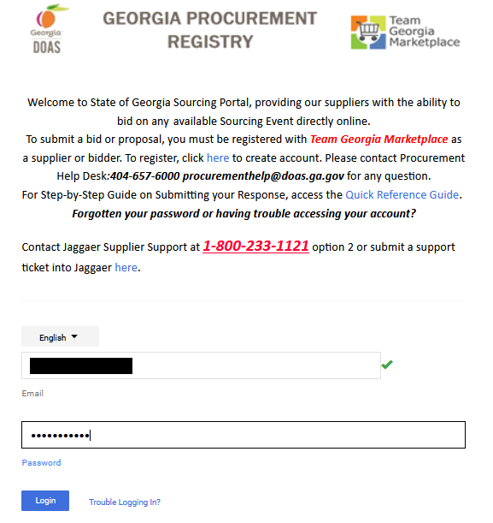
- Event Summary page will launch, and system will prompt Supplier to click on Click Yes, I intent to Bid or No Bid.  Supplier must click on Click Yes, I intent to Bid. | 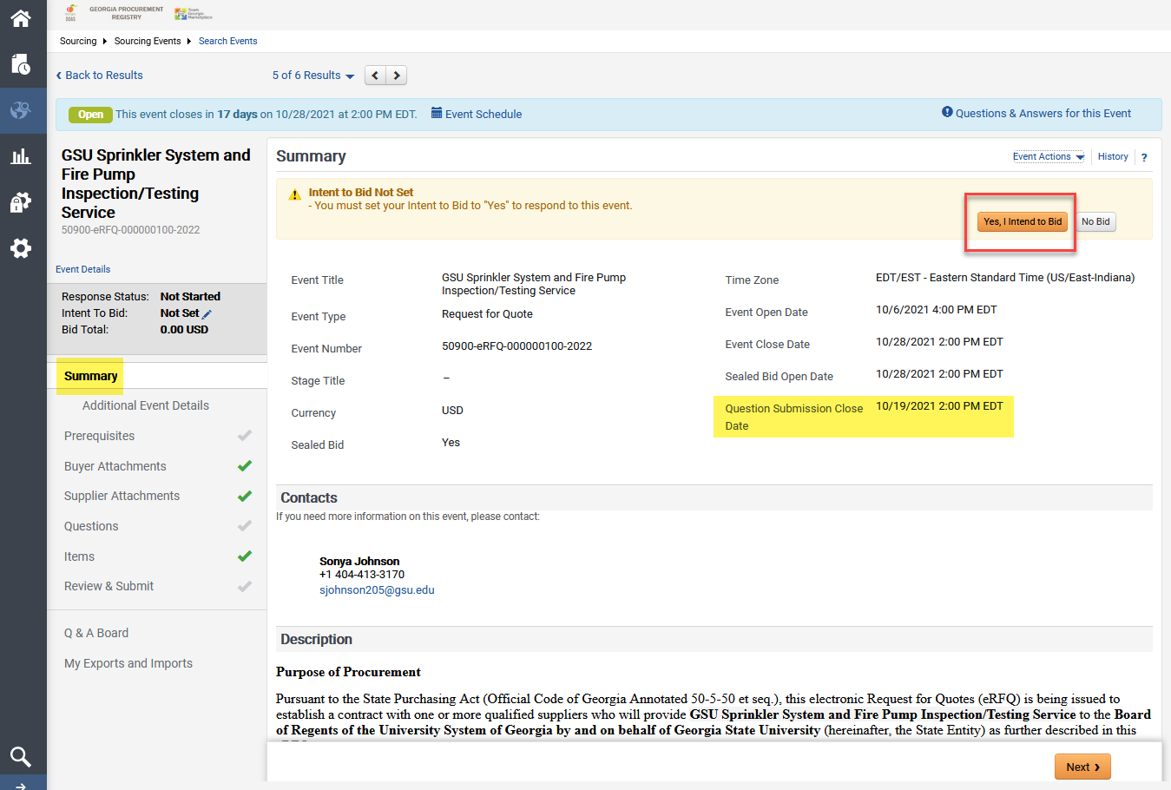

- Supplier can click on Q & A Board to communicate with issuing officer.  - The Q & A period might close prior to the event closing date/time. If the Q & A Board is closed, the option, Ask a Question, will not be available. Any question posted to the Q & A Board will be answered and will be posted to the public. | 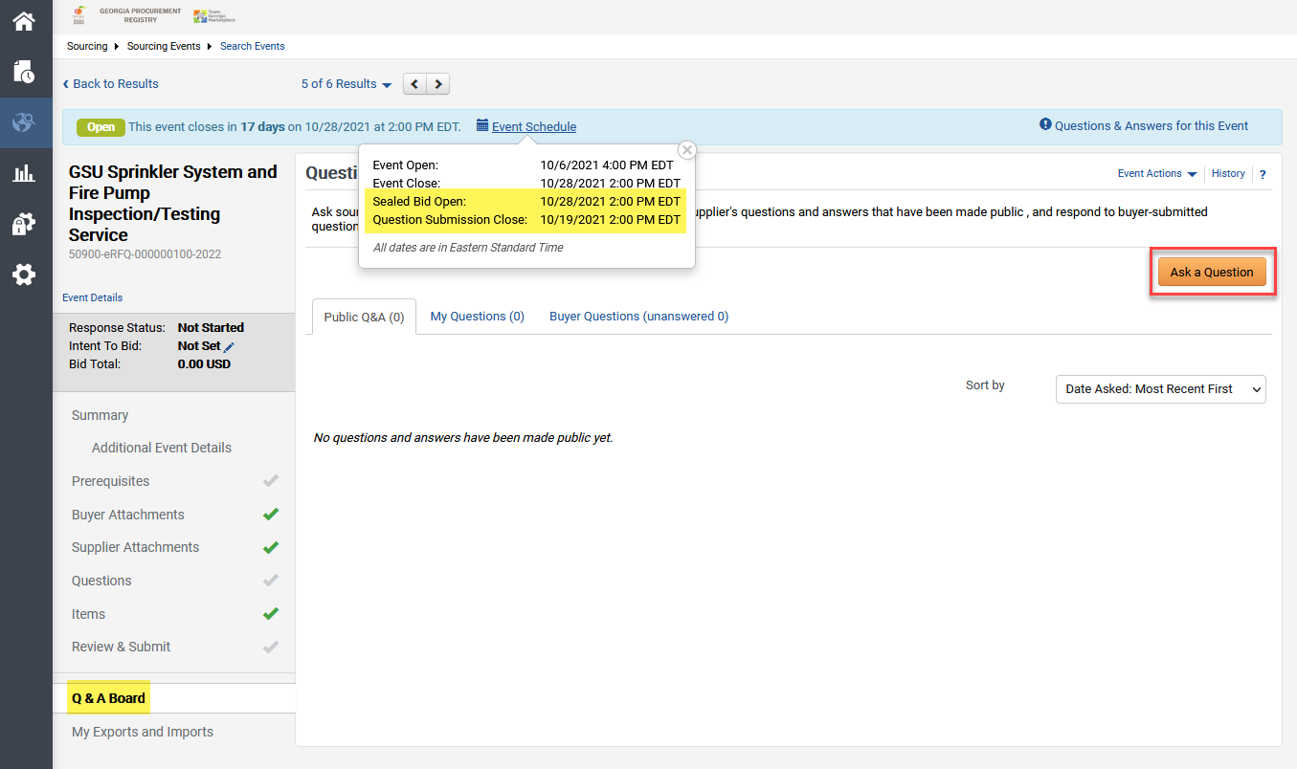  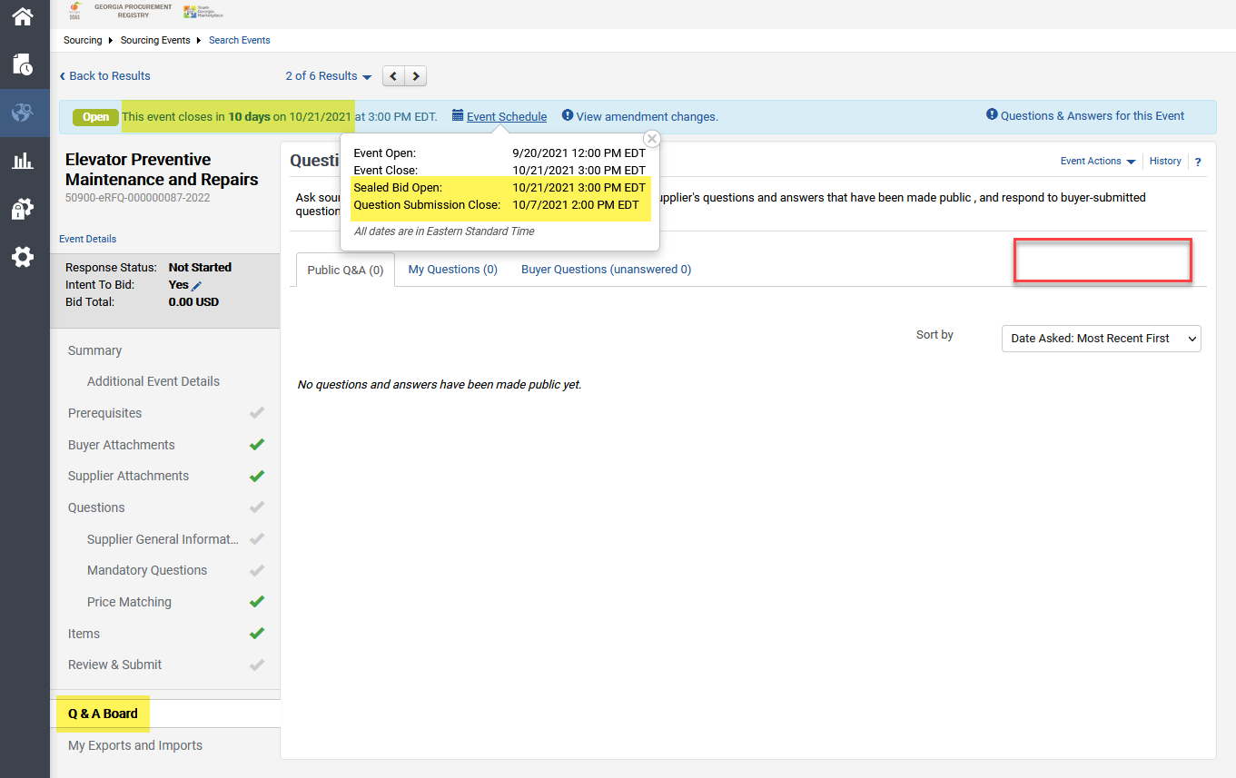
- Supplier can click on Ask a Question.  Enter Subject, Question and optionally upload attachment as needed.  Buyer will receive email alert only if Supplier has intent to bid selected as Yes. | 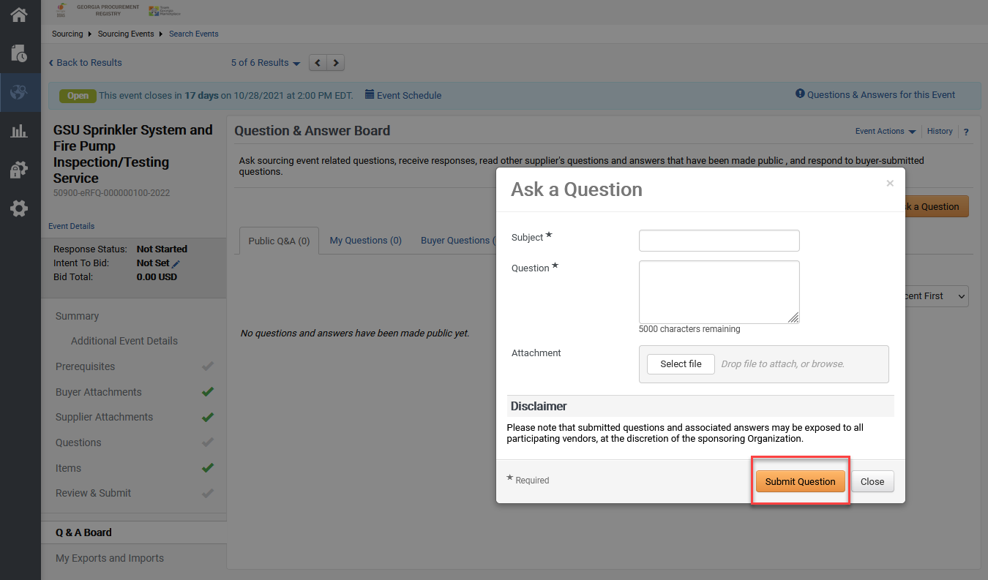

- Questions asked by logged in Supplier will be visible under My Questions tab.  The supplier may withdraw the question until it is answered.  Sourcing Buyer will receive an email alert. | 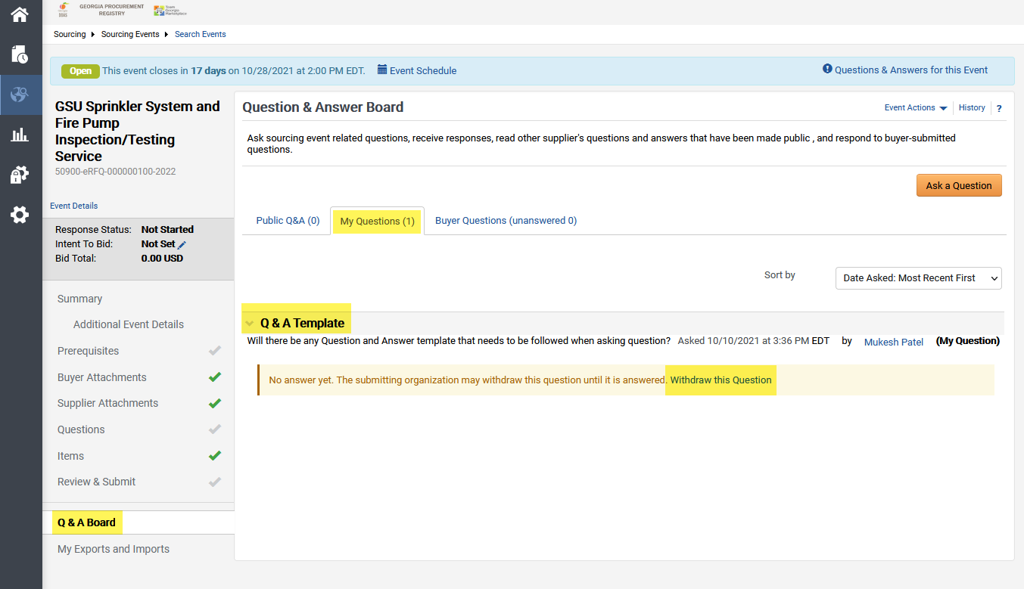  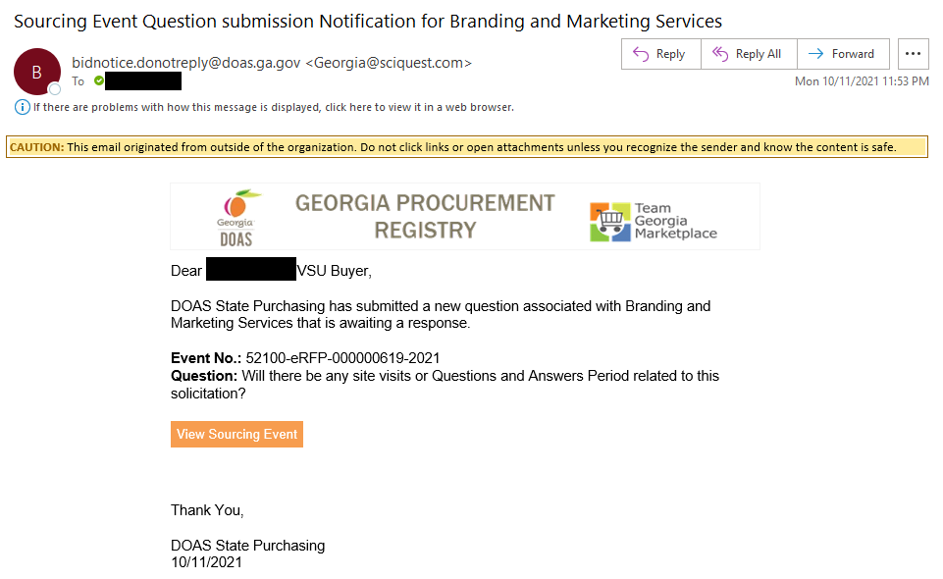
- Supplier Contact will receive an email alert when Buyer answered or respond to the question.  - Alternatively, Logged Supplier can click on Notification icon to find received Notification’s information. | 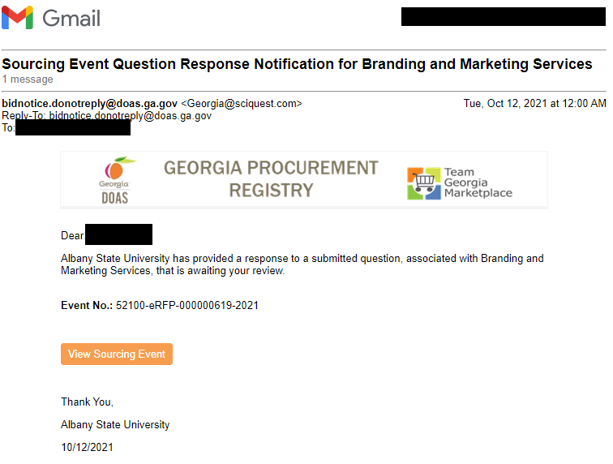  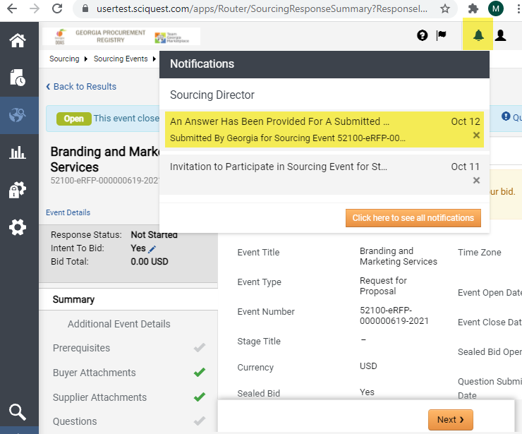
- Supplier receive the emails when Buyer posted Public Questions. | 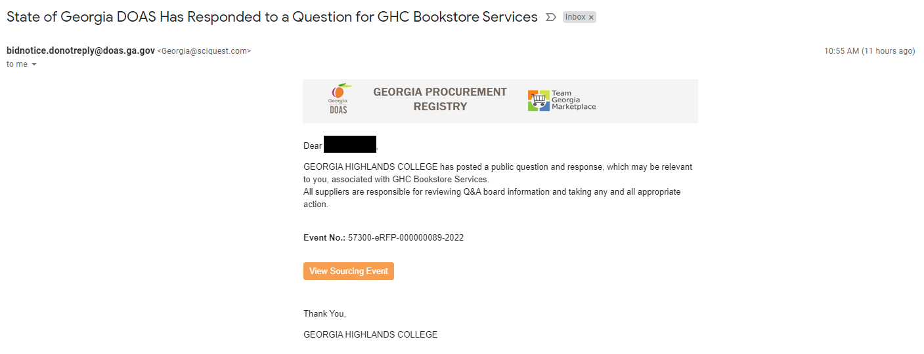
- Click on Public Q&A tab to know publicly answered Questions and Answers.  Some answers may be in the attachment format. | 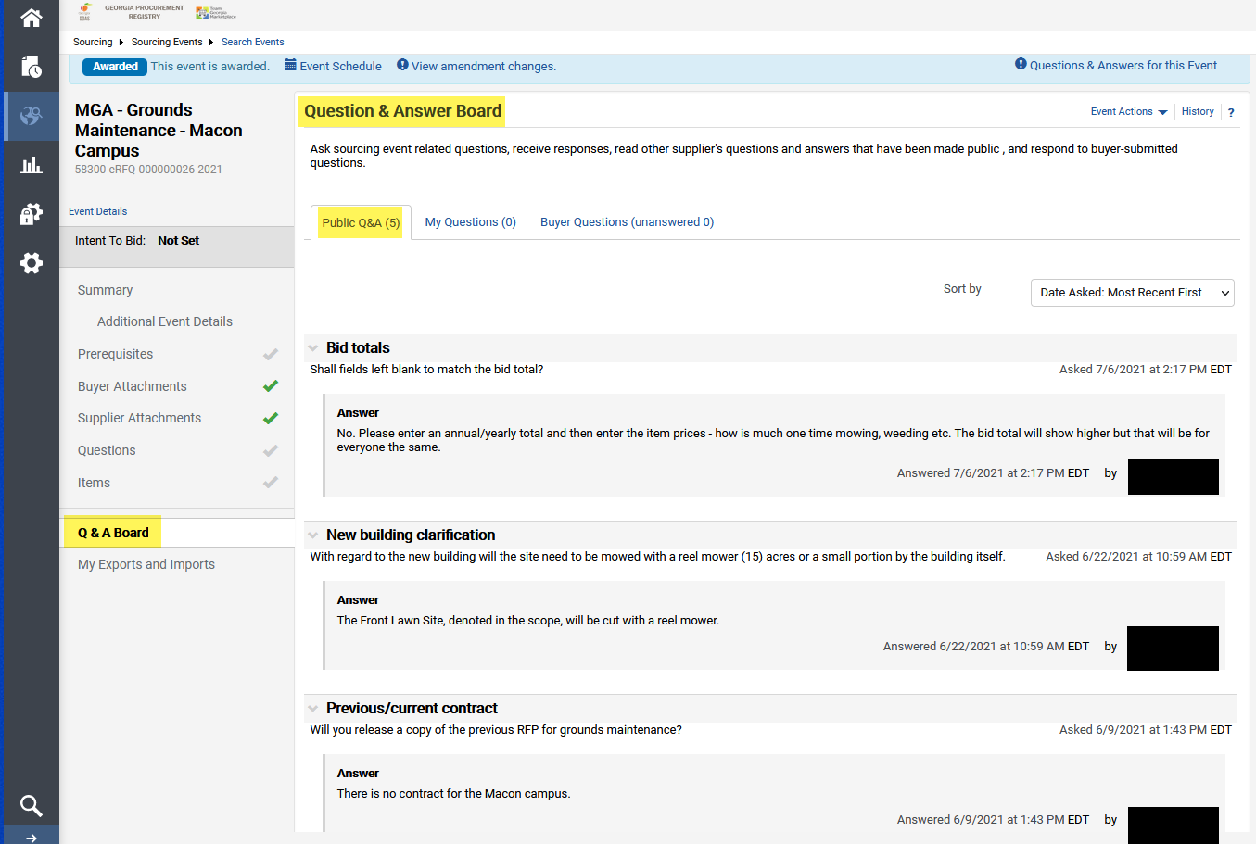  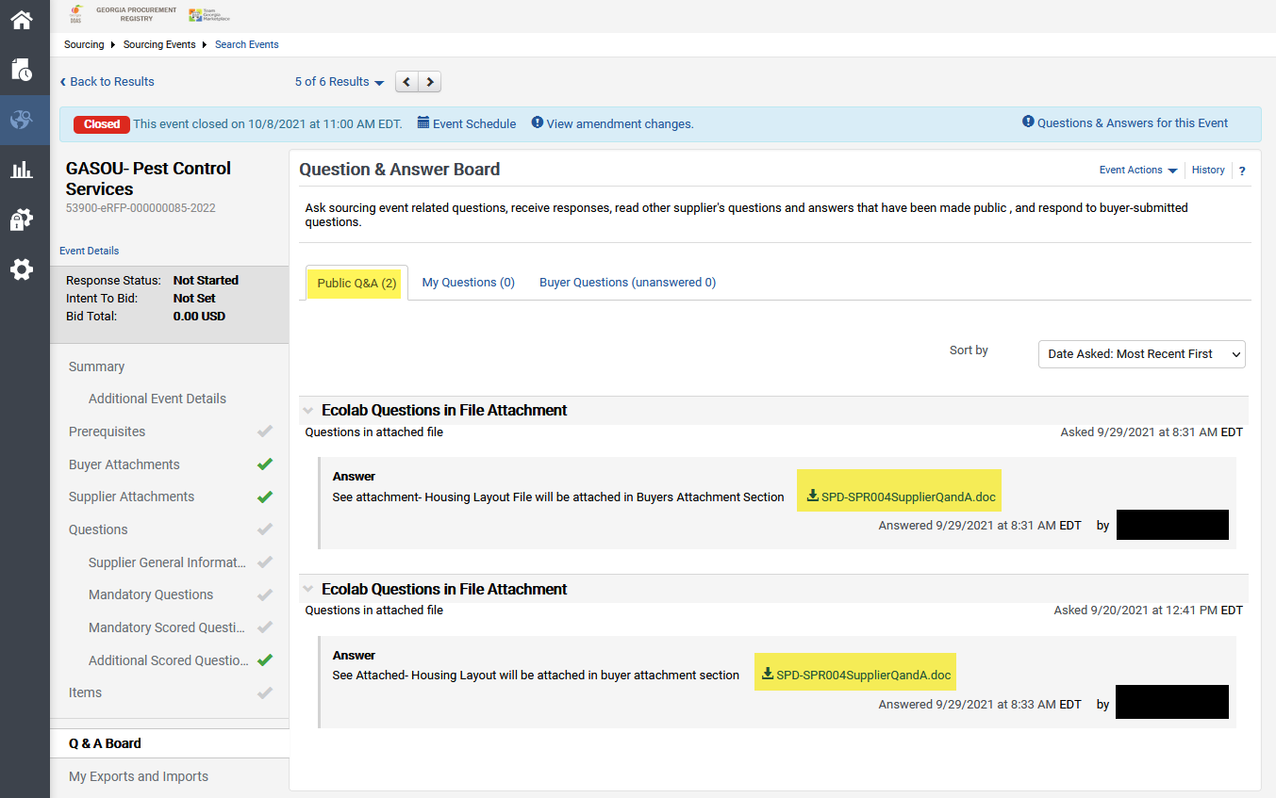  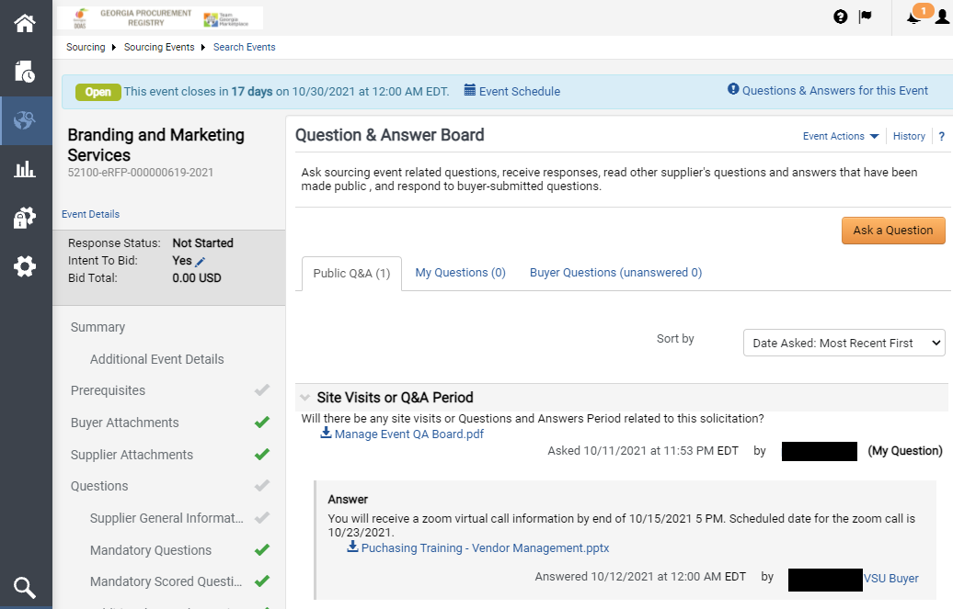  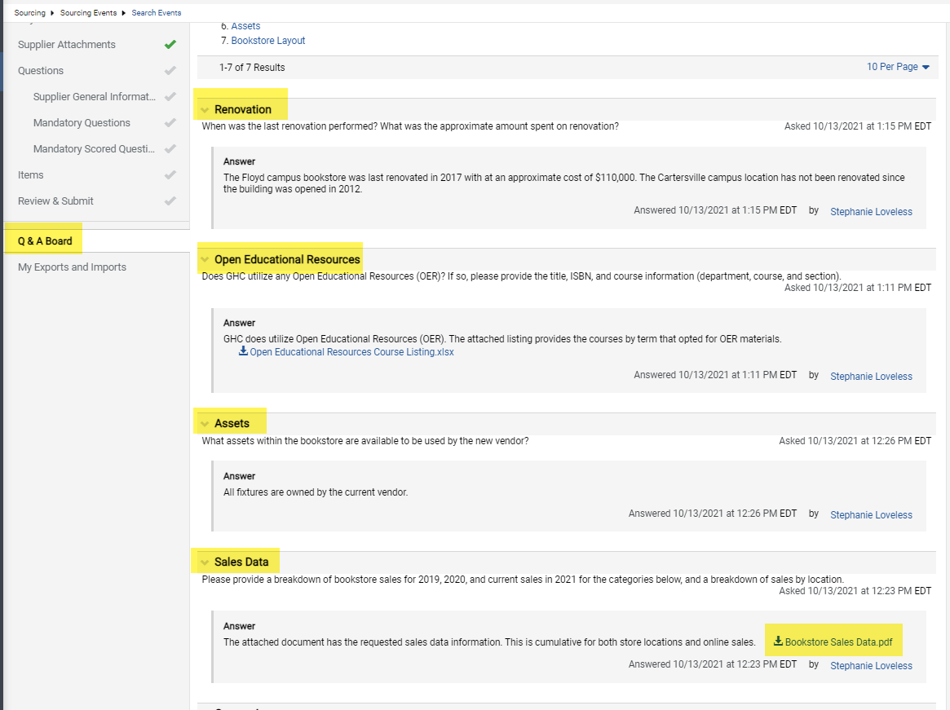
- Complete

